# Running DreamGrid On A Server

One of the difficulties in moving to a server such as Contabo.com is moving the files to it.

The big problem is mysql\data\ibdata - which is literally your grid and must be moved.

There are many ways to do this: Google drive, dropbox, ftp, but most of those require $$ or are very slow.  A very good way is to use Windows SMB file sharing.

The remote server can appear as a local disk, such as X: or Z: with SMB file shares so you can copy and paste files.  This makes it trivially easy to make backups and move OARs and backups off Contabo and store them at your home.

## Log Into Your Server

Log in with remote desktop or VNC  as an Administrator.   You need a strong password for your account!   Don't skimp on this step, as your server is exposed to the internet in an intimate way, and it will be probed constantly for weaknesses.  
  
Now choose a folder.  The safest way to share is by making a shared folder, such as your AUTOBACKUP folder.  If someone guesses your password, then all they get are backups. And you can share the entire drive, too.  
  
Right click a folder or C: and select Properties.  
  
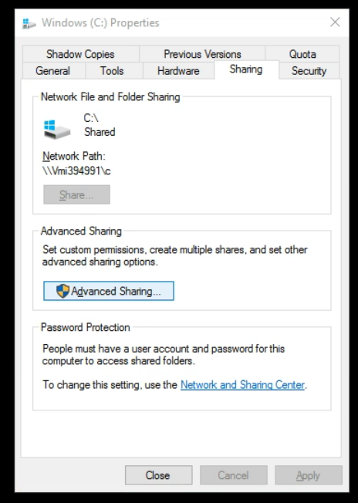

Click Advanced Sharing:  
  
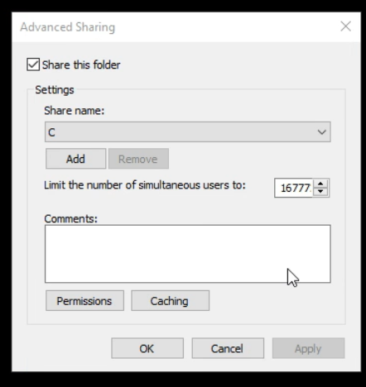  
  
Click Add and give it a name, such as "C", and check "Share this folder"  
  
Click Permissions:  
  
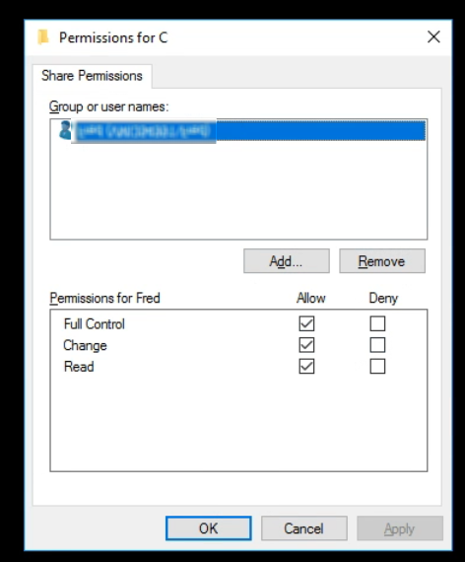  
  
  
Remove the "Everyone" group and  click Add and type in your login name.  
  
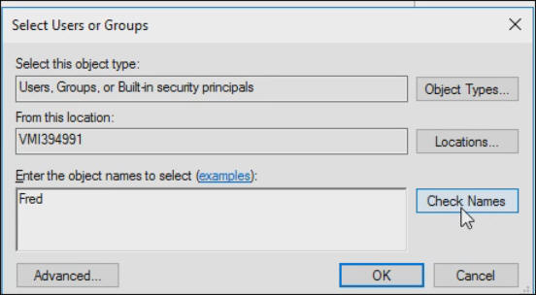  
  
Press OK  
  
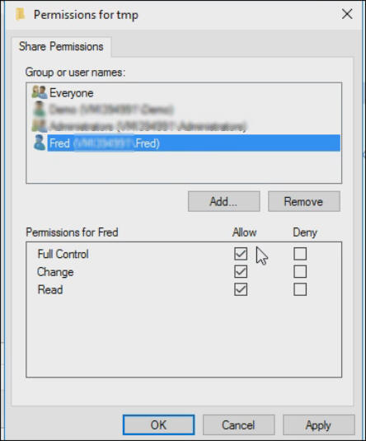  
  
Check "Full control" so all three permissions are lit up.  
  
Click OK

## Firewall Rules

You need to enable some ports in Windows Server.   Go to Control panel or search for Advanced Firewall.  
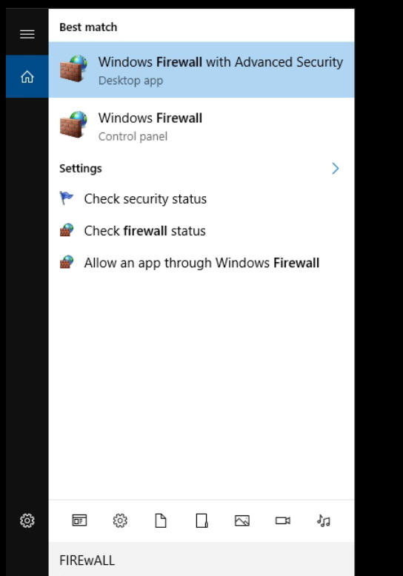  
  
In the firewall screen, click Inbound Rules  
  
  
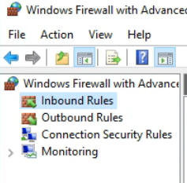

On the right side, click New Rule  
  
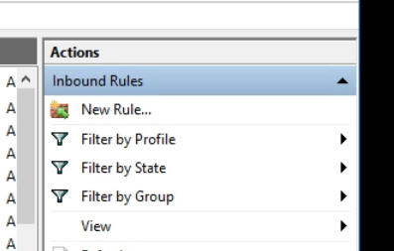  
  
Give it a name such as "File Sharing TCP"  
  
  
In Protocols and Ports  Select TCP and add the following ports: 134-139, 445, 389, 88  
  
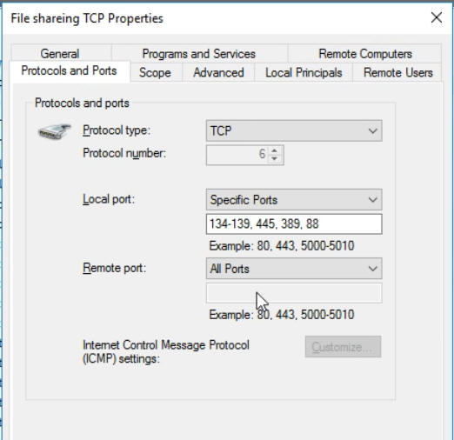  
  
  
Repeat the above steps for a name such as "File Sharing UDP"  
  
  
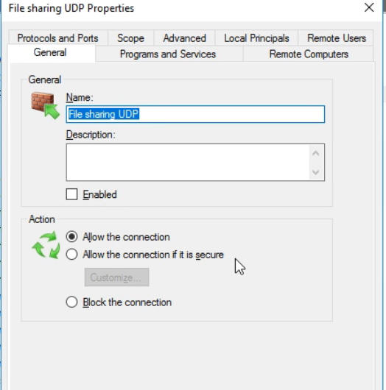  
  
Repeat the step "Protocols and Ports" Select UDP and add the following ports:  
  
134-139, 445, 389, 88  
  
  
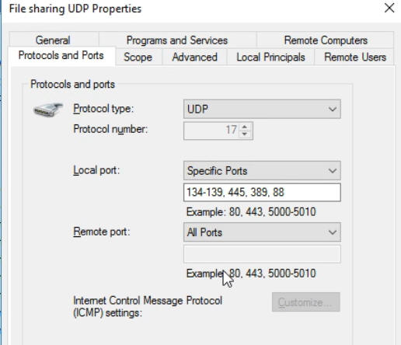  
  
Click Apply

# Sharing Files To And From Your Server

To connect, you can use the IP, DNS name, or Outworldz.net name.  This is the same name you connect to Contabo  in VNC or Remote Desktop,

Go to File Explorer in Windows at your Home PC. You can get there by pressing the Windows Logo key and the 'e' key at the same time.

Type two back slashes \\ in the address bar and then the  name of your server:

You should get a password prompt:

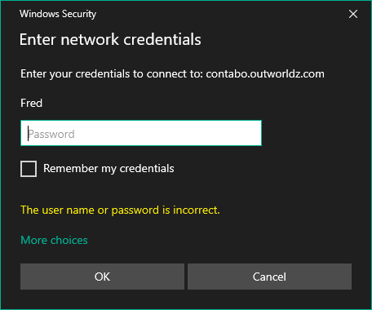

Enter your password and you should see the share name that you set up.

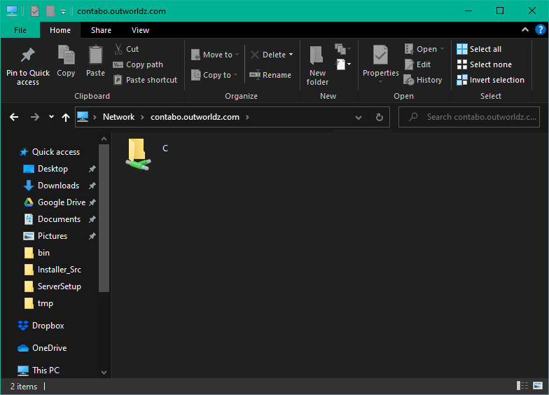

You can use this name and path as if it is local to your PC and drag and drop files to it. Or Copy and Paste.

You can also Map a drive letter to it.

Right click the folder and select "Map Network Drive"

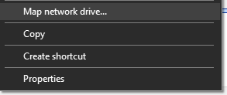

 Choose a drive letter and click Apply

Now you can simply go to the drive letter and access your server.

# Backups:

Now that your server is set up for file access, you can use programs such as  robocopy (free, built into windows), and paid backup programs such as SyncBack to mov e or copy your grid to your home PC on a regular basis.

Example: I created map drive as X: to a folder on the server and added a batch file named Backup.bat.

I then ran this from the server as X:/backup.bat and it copied my Servers X:\tmp folder to my home PC C:\tmp folder.

You can now use robocopy to backup your entire grid, or the Backup folder with one simple command "X:/Backup" by changing the folder names in the batch file.

PS X:\> .\Backup.bat  
  
X:\>robocopy X:\tmp c:\tmp /e  
  
-------------------------------------------------------------------------------  
ROBOCOPY :: Robust File Copy for Windows  
-------------------------------------------------------------------------------  
  
Started : Monday, October 19, 2020 11:38:27 PM  
Source : X:\tmp\  
Dest : c:\tmp\  
  
Files : *.*  
  
Options : *.* /S /E /DCOPY:DA /COPY:DAT /R:1000000 /W:30  
  
------------------------------------------------------------------------------  
  
0 X:\tmp\  
New Dir 0 X:\tmp\A\  
  
-----------------------------------------------------------------------------  
  
Total Copied Skipped Mismatch FAILED Extras  
Dirs : 2 1 1 0 0 1  
Files : 0 0 0 0 0 8  
Bytes : 0 0 0 0 0 27.63 m  
Times : 0:00:00 0:00:00 0:00:00 0:00:00  
Ended : Monday, October 19, 2020 11:38:28 PM  
PS X:\>